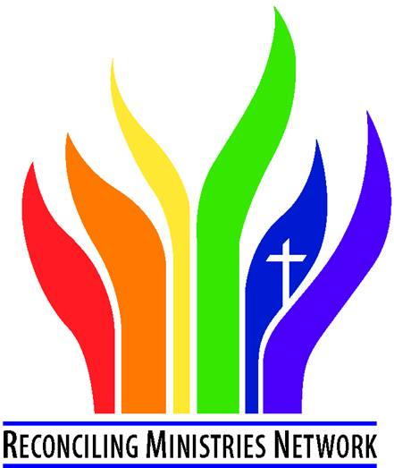

**Oregon-Idaho Reconciling United Methodists (OI RUMs) meet via Zoom**

**Saturday, March 22, 2025**

**2 pm Pacific time / 3 pm Mountain time**

RMN Organizer the Rev. Dr. Israel (“Izzy”) Alvaran will update us about RMN’s restructure and pivot in the post-General Conference context with continuing support of the Reconciling movement toward a UMC that is inclusive and affirming of all God’s children across our UM connection.

He will also share what the RMN is doing to respond to the current moment in our country and listen to what local RUMs need as support.

**Zoom link: https://us02web.zoom.us/j/83055305363**

**Meeting ID: 830 5530 5363**

**Visit us at www.OIRUMS.org**