TITLE: SINGLE-USER, GENDER-NEUTRAL, ACCESSIBLE, LOCKABLE REST ROOMS

SPONSORING GROUP OR INDIVIDUAL: Oregon-Idaho Reconciling United Methodists

SPOKESPERSON: Deborah Maria

SPOKESPERSON’S ADDRESS: 773 Nicole Drive, West Linn OR 97068

SPOKESPERSON’S E-MAIL: yourbest@juno.com

SPOKESPERSON’S TELEPHONE: 503.723.0058

I/We petition the Oregon-Idaho Annual conference to take the following action:
In order to provide facilities that protect human dignity, offer safe spaces, and equalize access, we recommend that each United Methodist Church (UMC) in the Oregon-Idaho Annual Conference by 2020 have at least one rest room in each church building designated as single user, gender neutral, accessible, and lockable. Each congregation will be invited to report its progress toward this goal for each session of Annual Conference.

We also request that churches add a child-sized commode and lavatory where this is feasible.

______________________________________________________________________________________________________

SUPPORTING INFORMATION
Our Conference holds that our churches and facilities (buildings, gathering spaces, offices, etc) are safe places for all regardless of age, ability, gender, and other personal characteristics.

The United Methodist Church is a people of open hearts, open minds and open doors -- a church that practices radical hospitality. As such, we raise the bar so that our churches in Oregon and Idaho equal or exceed practices of personal and family care.

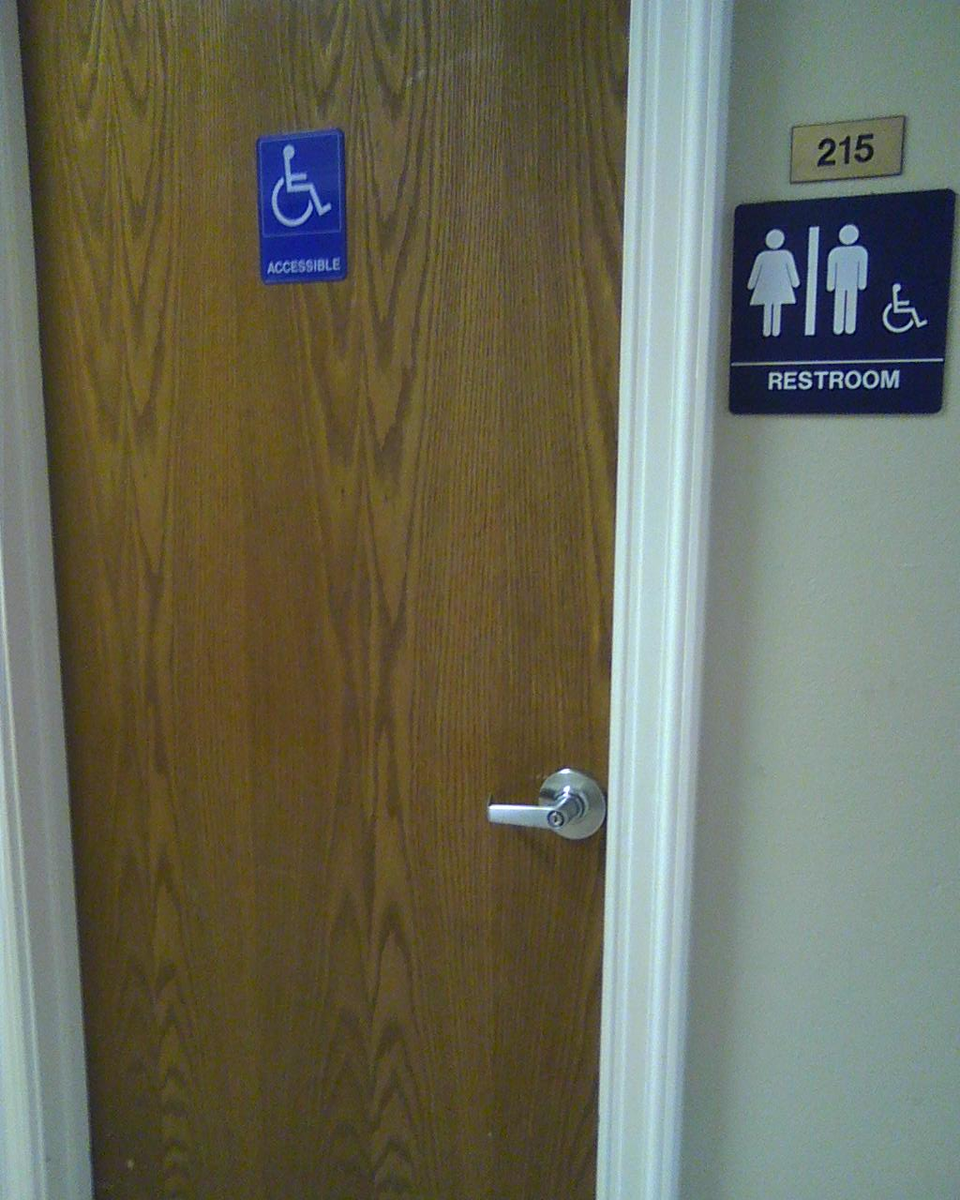

What will this action accomplish?
Developing a gender-neutral, single-user, accessible, lockable rest room in each Oregon-Idaho UMC will serve our members and visitors in these ways and possibly more:
- where assistance of another person is needed for an adult/youth/child with physical or other needs
- family-friendly for parents with infants/toddlers
- use by anyone whose health, social, medical, or other needs mandate a single-person rest room

Why is it important?
To ensure that all members and visitors can take care of themselves and their families on site without embarrassment.

How will it be carried out? By whom?
By the Trustees, health care teams, and other local congregational groups that oversee building use and welcoming policies and actions.

Even though this request is directed to congregations, other entities of the United Methodist Church in Oregon-Idaho are encouraged to implement this action to the greatest extent possible – Camp and Retreat Ministries at each site, campus ministries, the Conference and District offices, and so forth.

How much will it cost? Where will the money come from?
Cost will vary depending on the retrofitting/remodeling/outfitting needs of each site. Each site will have the flexibility to develop its own plan.

Approved by Oregon-Idaho Annual Conference Session June 12, 2015, with “require” changed to “recommend” on line 10

